The data set I am using for this discussion is the Breast Cancer data set. There are ten variables and red signifies patients that have cancer.

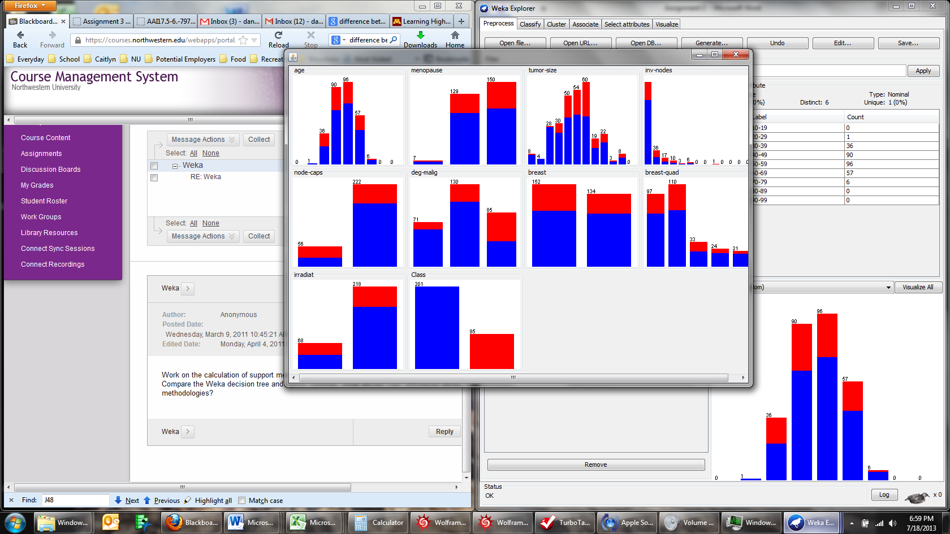

=== Run information ===

Scheme: weka.associations.Apriori -N 10 -T 0 -C 0.9 -D 0.05 -U 1.0 -M 0.1 -S -1.0 -c -1

Relation: breast-cancer

Instances: 286

Attributes: 10

age

menopause

tumor-size

inv-nodes

node-caps

deg-malig

breast

breast-quad

irradiat

Class

=== Associator model (full training set) ===

Apriori

=======

Minimum support: 0.5 (143 instances)

Minimum metric <confidence>: 0.9

Number of cycles performed: 10

Generated sets of large itemsets:

Size of set of large itemsets L(1): 6

Size of set of large itemsets L(2): 6

Size of set of large itemsets L(3): 4

Size of set of large itemsets L(4): 1

Best rules found:

1. inv-nodes=0-2 irradiat=no Class=no-recurrence-events 147 ==> node-caps=no 145 conf:(0.99)

2. inv-nodes=0-2 irradiat=no 183 ==> node-caps=no 177 conf:(0.97)

3. node-caps=no irradiat=no Class=no-recurrence-events 151 ==> inv-nodes=0-2 145 conf:(0.96)

4. inv-nodes=0-2 Class=no-recurrence-events 167 ==> node-caps=no 160 conf:(0.96)

5. inv-nodes=0-2 213 ==> node-caps=no 201 conf:(0.94)

6. node-caps=no irradiat=no 188 ==> inv-nodes=0-2 177 conf:(0.94)

7. node-caps=no Class=no-recurrence-events 171 ==> inv-nodes=0-2 160 conf:(0.94)

8. irradiat=no Class=no-recurrence-events 164 ==> node-caps=no 151 conf:(0.92)

9. inv-nodes=0-2 node-caps=no Class=no-recurrence-events 160 ==> irradiat=no 145 conf:(0.91)

10. node-caps=no 222 ==> inv-nodes=0-2 201 conf:(0.91)

J48 Process

=== Run information ===

Scheme:weka.classifiers.trees.J48 -C 0.25 -M 2

Relation: breast-cancer

Instances: 286

Attributes: 10

age

menopause

tumor-size

inv-nodes

node-caps

deg-malig

breast

breast-quad

irradiat

Class

Test mode:10-fold cross-validation

=== Classifier model (full training set) ===

J48 pruned tree

------------------

node-caps = yes

| deg-malig = 1: recurrence-events (1.01/0.4)

| deg-malig = 2: no-recurrence-events (26.2/8.0)

| deg-malig = 3: recurrence-events (30.4/7.4)

node-caps = no: no-recurrence-events (228.39/53.4)

Number of Leaves : 4

Size of the tree : 6

Time taken to build model: 0.01 seconds

=== Stratified cross-validation ===

=== Summary ===

Correctly Classified Instances 216 75.5245 %

Incorrectly Classified Instances 70 24.4755 %

Kappa statistic 0.2826

Mean absolute error 0.3676

Root mean squared error 0.4324

Relative absolute error 87.8635 %

Root relative squared error 94.6093 %

Total Number of Instances 286

=== Detailed Accuracy By Class ===

TP Rate FP Rate Precision Recall F-Measure ROC Area Class

0.96 0.729 0.757 0.96 0.846 0.584 no-recurrence-events

0.271 0.04 0.742 0.271 0.397 0.584 recurrence-events

Weighted Avg. 0.755 0.524 0.752 0.755 0.713 0.584

=== Confusion Matrix ===

a b <-- classified as

193 8 | a = no-recurrence-events

62 23 | b = recurrence-events

Analysis

J48 Utilizes a top down approach while the Apiori method analyzes all the data from an association standpoint.

Final thoughts:

Support is often the same if one switches between the consequent and antecedent value. While this remains the same, the confidence changes based on frequency as well as the size of the greater population. In my opinion, this can be misleading with the potential for manipulation. Lift follows the same pattern as support in that the order of the antecedent and consequent remain the same.